MS Fabric Data flow

Introduction
This is a low code ETL tool (Extract Transform load) in power query experience with possibilities to connect to various sources like below and extrat data.

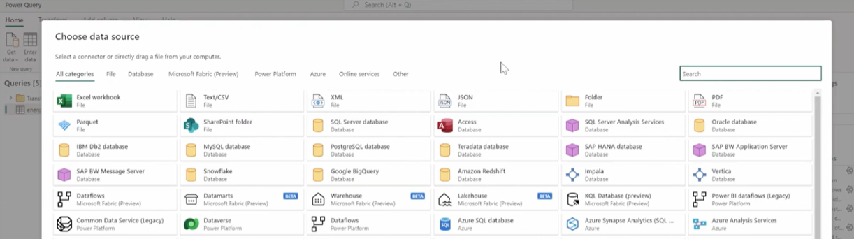

Note :
- This tool is good to be used to transformation on small data set (table , files..) to limitate the performance issue.
- For Ingestions use Spark (notbooks) , pipeline..and the ouput data can be transform by a Data Flow (if the amount of data is not too huge)

Ref : https://www.youtube.com/watch?v=SH68cHf7oOY

Fabrics Data flow (Gen2) vs Power BI Data flow (Gen1)
Like power Bi DataFlow, fabric data flow can perform lot of extract and transforming data experiences, but the big deference is that Frabric can load the transformed data to a fabric location like Lakehouse and Warehoiuses

Fabric DataFlow performance
In term of performance the fabric data flow ETL process in low today (but in improvement process by Microsoft). The below comparisons can give some ideas:

